LAB-8 DHCP
ROUTER-1
ROUTER CONFIGURATION:
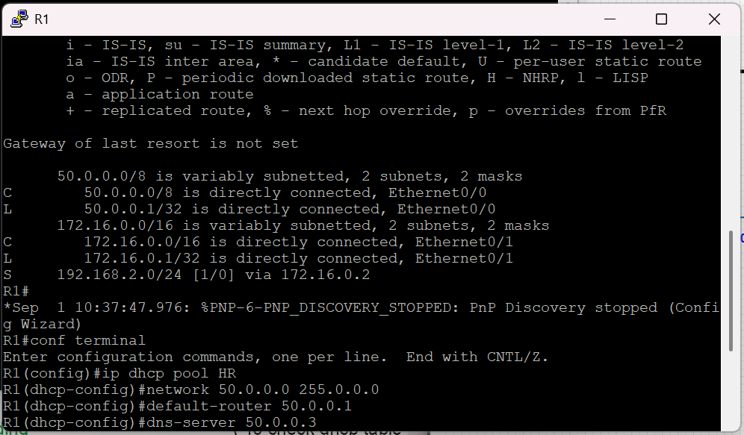

ENABLE DHCP SERVER IN R1 FOR HR DEPARTMENT

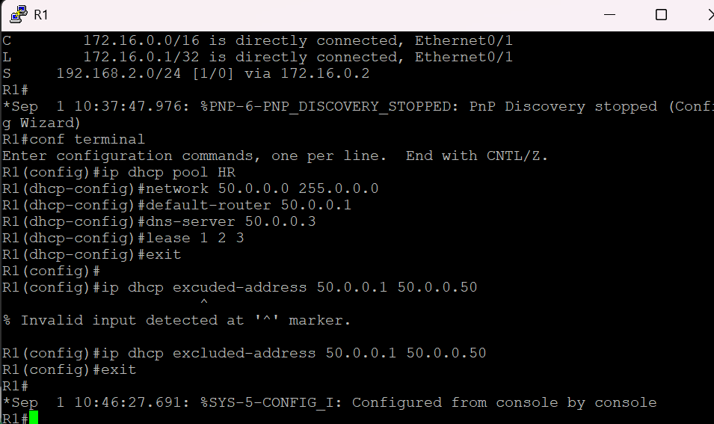

OUTPUT FROM VPC-1 AND VPC-2

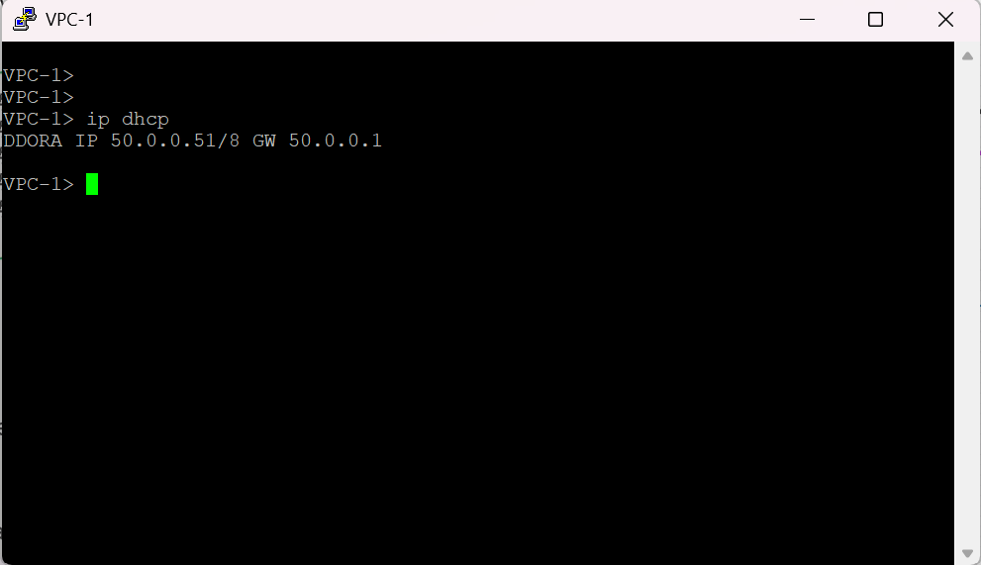

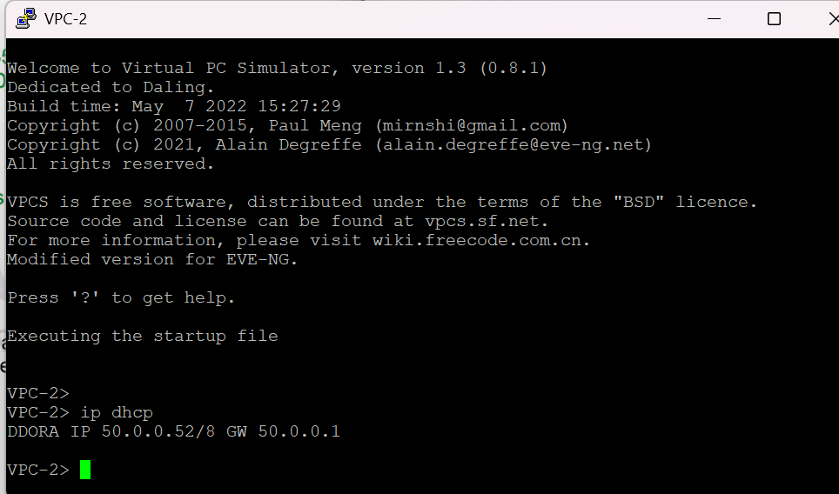

Enable dhcp server for SALES department in same R1:
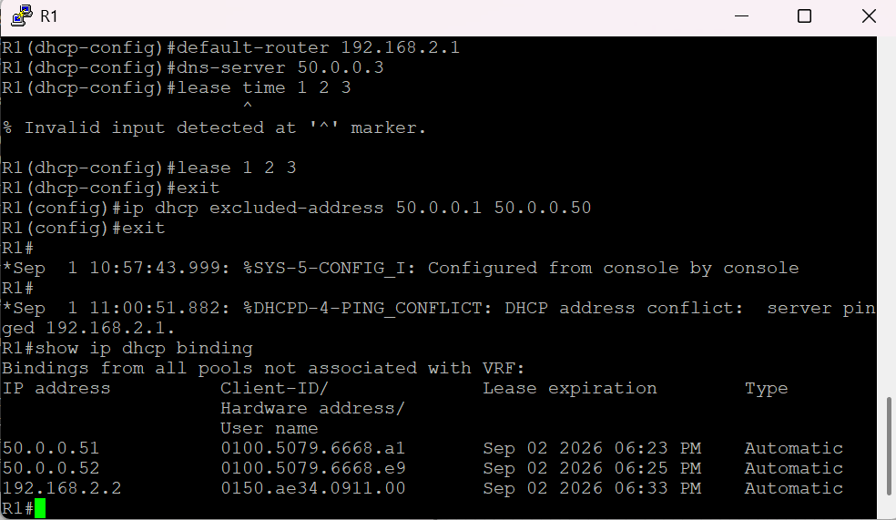

Enable dhcp relay agent on router 2 client connected interface:
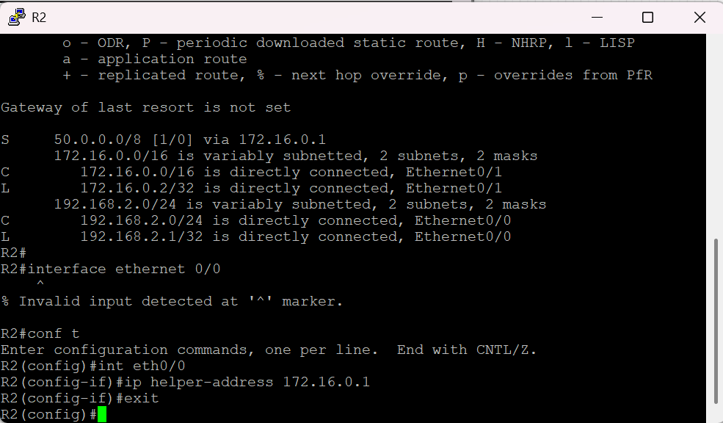

OUTPUT:

